GR8677 Questions 1-10

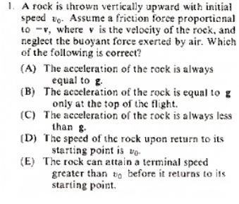

Answer : B. Note the object is thrown vertically upward. So at top, velocity equal zero----air resistance is not in play. Done.

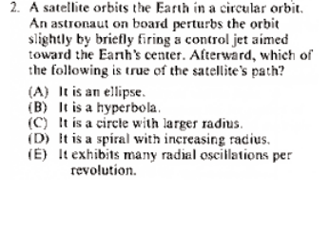

Answer: A ---comments. Orbits must be conic sections (circle, ellipse, parabola, hyperbola). Assumed from question that the circular orbit is given a minor nudge---It would take a major perturbation to have satellite become free.

Spiral does not occur without damping. Radial oscillations require an ongoing force.

Note that the mass of the Earth is ignored and considered negligible, otherwise there is a “wobble” in the orbit.

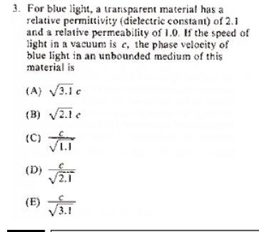

Speed of light=1/sqrt(permittivity*permeability). D

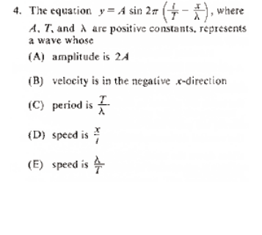
Answer E. The amplitude is A. Waves with +, - signs (either order) are right going. Period is T. x and t are variables.

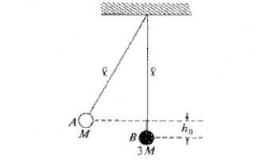
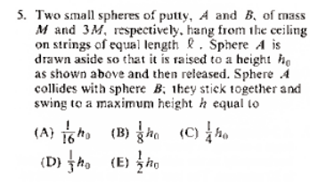
THIS IS A ---I KNOW HOW BUT COME BACK TO WITH TIME ---MUST WORK IT OUT.

This is much like our ballistic pendulum lab.
I’ll copy posted solution but comment first.
- Find speed at bottom of swing for first mass prior to collision.
- Use conservation of momentum to find speed of mass 4M stuck together immediately after collision.
- Convert all KE after collision to PE.

There is a shorter momentum discussion on the site----note that discussion works but has some erroneous statements. IT DOES rely on being perfectly inelastic. The momentums right before and after collision can be handled as discussed.

POSTED SOLUTION From GRE Physics net.
This is a three step problem involving conservation of energy in steps one and three and conservation of momentum in step two.
1. ... Conservation of energy determines the velocity of putty A, , (of mass ) at the bottom of its trajectory, right before it intersects B.
2. ... Since the putty thingies stick together, conservation of momentum is easy. Solve for .
3. ... Conservation of energy, again. Solve for .
And voila, plug in the relevant quantities to find that the answer is (A) .

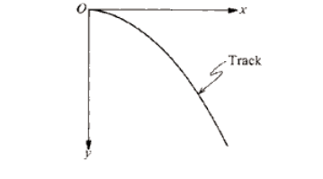

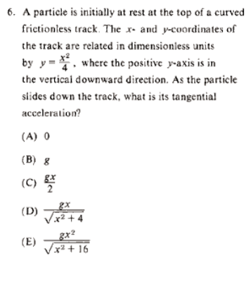

Answer D. For any ramp, the acceleration along the way is g sin(angle) Where sin(angle) represents the steepness of the ramp somehow. dy/dx=x/2=tan(angle). Tan=rise/run. Draw right triangle with vertical (rise) side x and horizontal side 2. Get D. Or recall trig identities, or derive (quickly). From Tan=sin / cos and sin^2 +cos^2=1 and eliminate cos, solve for sin.

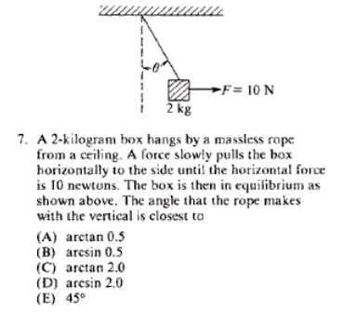

Answer A. mg~20Newtons. Tan~ 10/20.

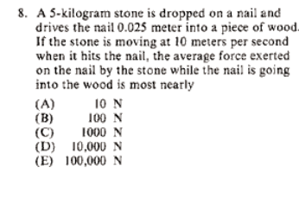

Note the rough range of numbers here. Order of magnitude. Note that the additional 0.025 m worth of potential energy of the stone can be ignored since it falls much further in picking up the 10m/s speed.

So, a=v^2/(2d)

And F=ma.

You get D for answer.

Also note that average means “Time average”. We could go back and compute time to cover the 0.025 m at an average speed of 5.0m/s. and get the same answer. In general this is not the same as the spatial average force. (Energy=Force average *displacement)

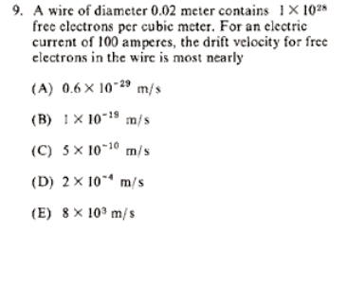

100*6.25E18charges/second. This must equal the number of charges per volume (rho) moving with speed v (drift spead). Across an area the diameter of the wire.

V=100*6.25E18/(1E28* pi*0.01^2)

Answer D

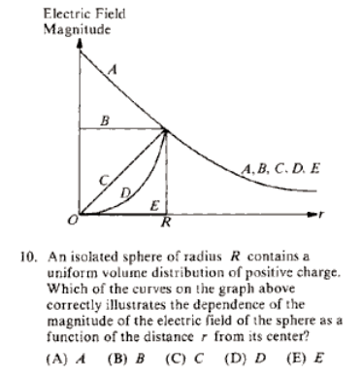

DO GAUSS LAW ON THIS.

